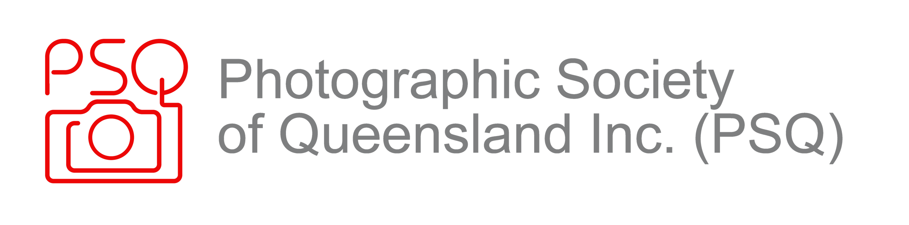
Feedback from Mentor to Understudy Judge on judging images:

USJ Name: | Mentor Name:
Club Name: | Date of Club Meeting
Subject/s Judged: | Grades: (A, AB, B, etc)
Overall Number of Images: | Type of Presentation? Live, Written, Zoom, etc:
What were two things that were good about the judging provided? EG. Presentation skills? Knowledge? Engagement with club members?
Did the USJ feedback include aspects of story, creativity and emotional content as well as technical aspects such as impact, composition, cropping and depth of field, etc? (Do not use yes/no answers)
Were awards given consistently, and with recognition to the different levels of expertise of Club Grades? (Do not use yes/no answers)
Were subject definitions provided by clubs adhered to, especially when different to mainstream definitions? (Do not use yes/no answers)
How did the USJ handle questions? (Live judging only): (Do not use yes/no answers)
Are there aspects of the USJ judging that the USJ could be improved?

