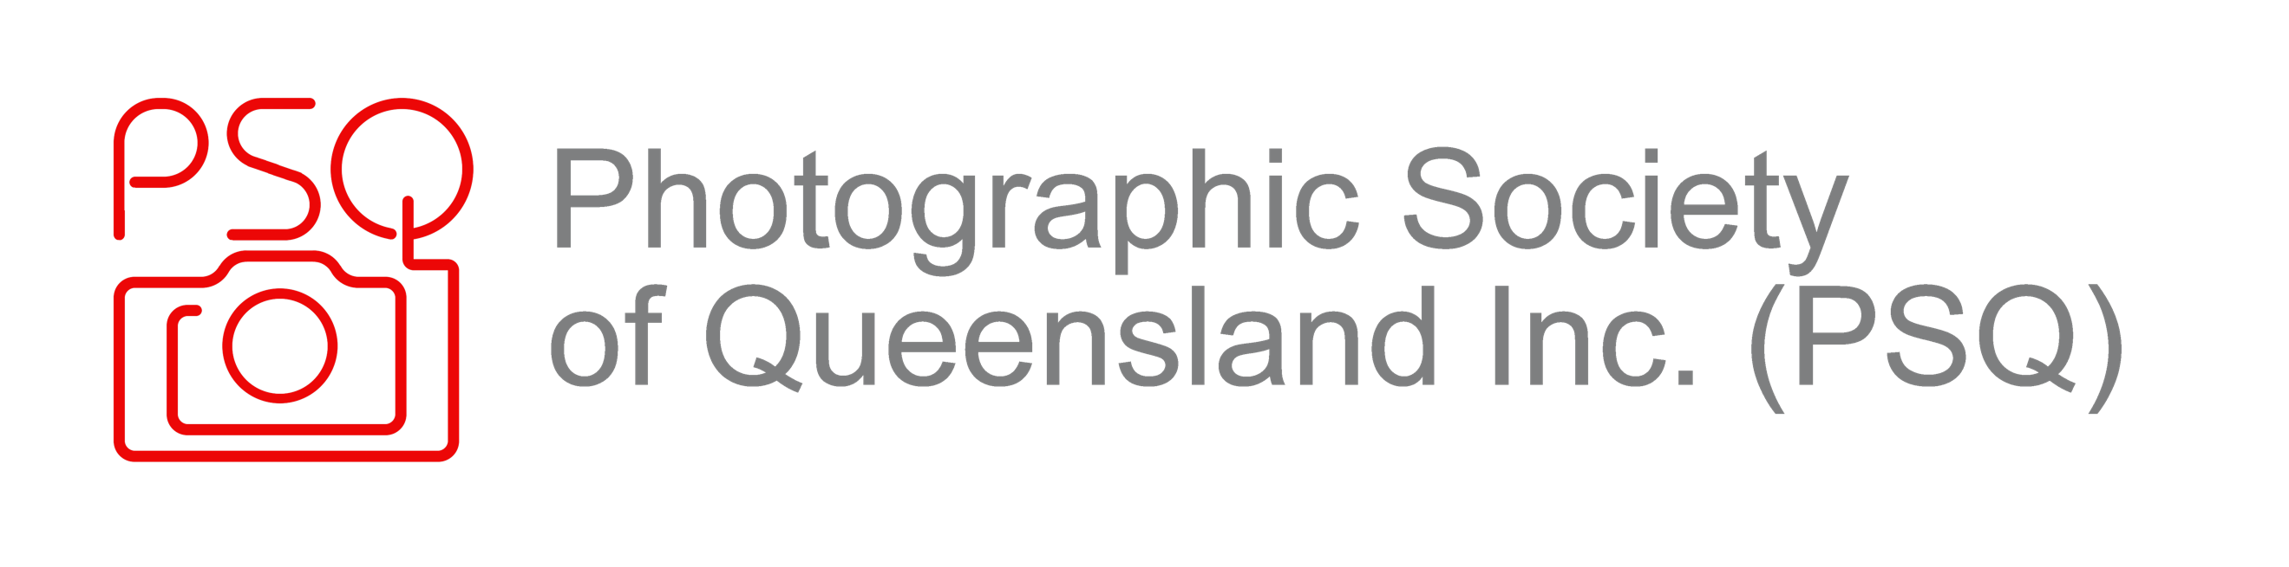
Feedback from Club to Understudy Judge on Presentation:

USJ Name: | Mentor Name:
Club Name: | Date of Club Meeting
Presentation Subject: | Method: In person? Zoom?
What were two things that were good about the presentation provided? EG. Presentation skills? Use of AV Equipment? Engagement with club members?
Did the USJ have good subject knowledge? (Do not use yes/no answers)
Was the presentation well researched and prepared?
How did the USJ handle questions?
Are there aspects of the USJ Presentation that the USJ could improve?

